**If you are interested in touring the Sheridan County Historical Museum, located in Goodrich, ND, Please contact one of the people listed below:**

**(There is the main museum, the school, and the main house to tour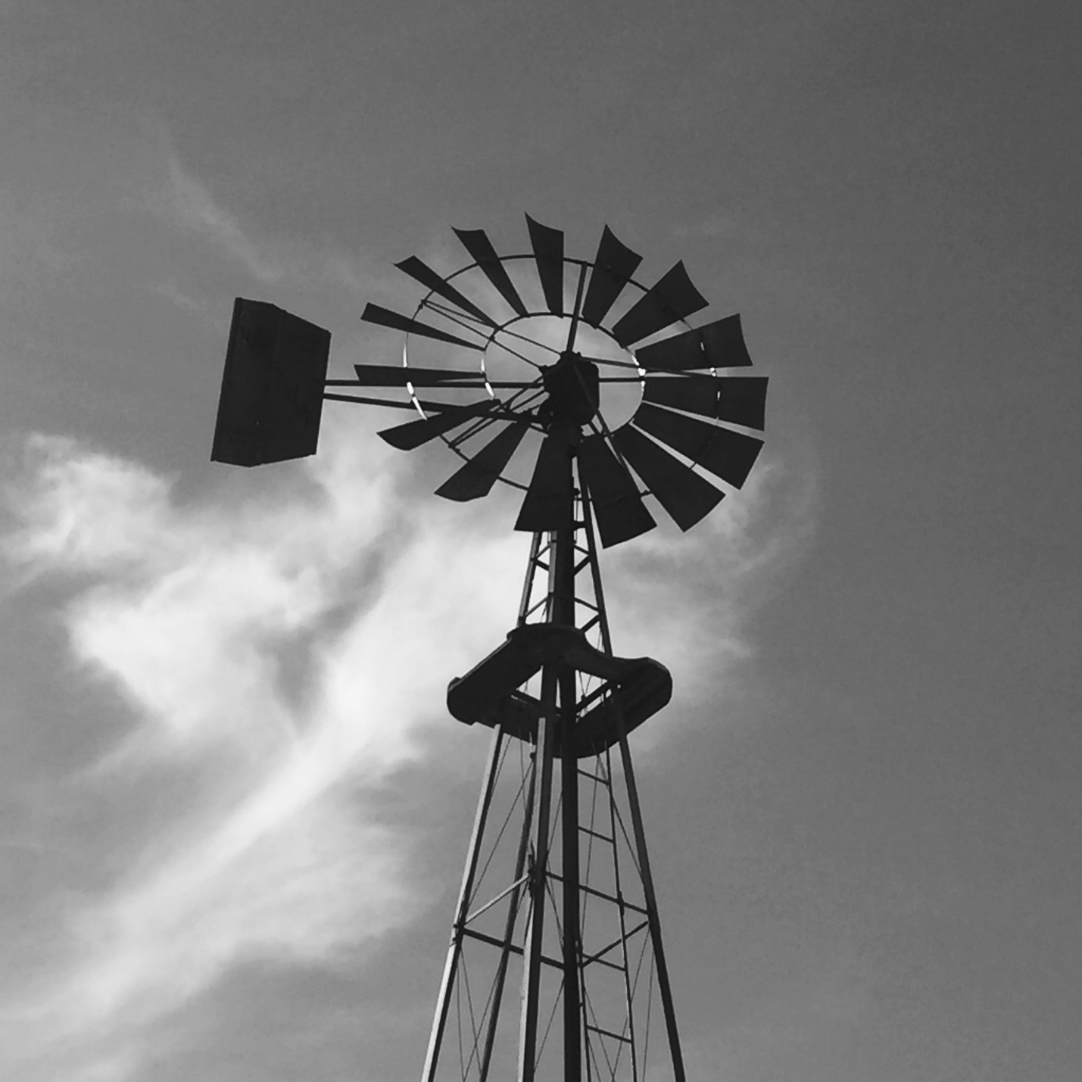)**

**Sylvia Schell-701-214-7103 or 701-363-2670**

**Connie Erdmann 701-884-2700**

**Don Hagen 701-884-2752**

**Tom Sauter 701-884-2437**

**Delilah Gesellchen 701-884-2457**